Year 11 Chemistry
AECHE

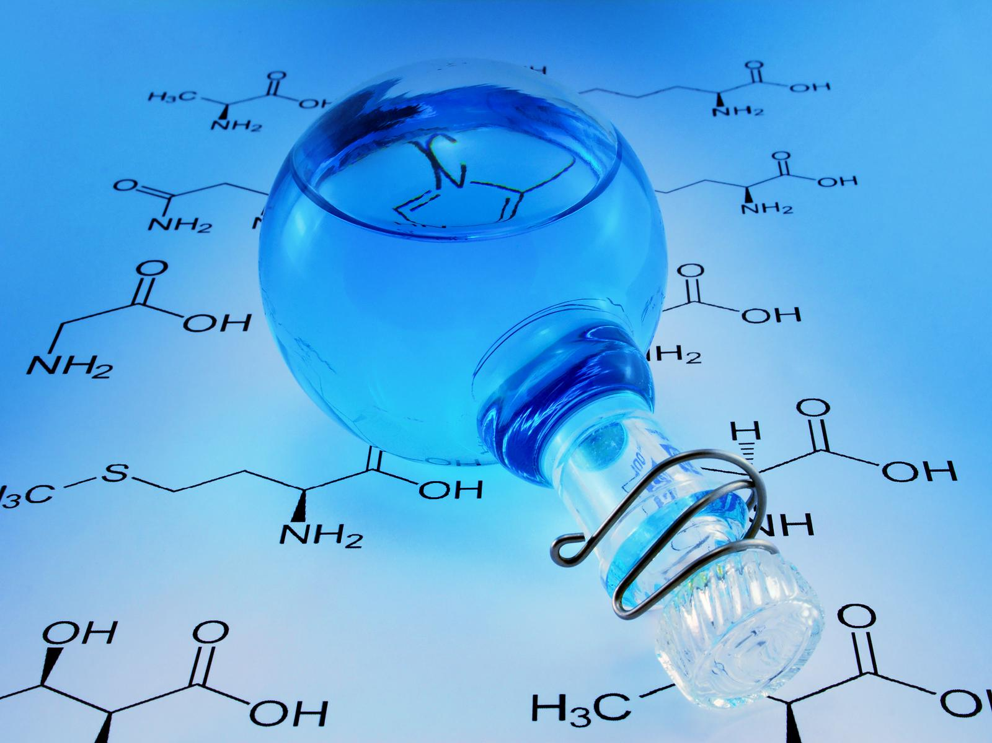

Organic Chemistry

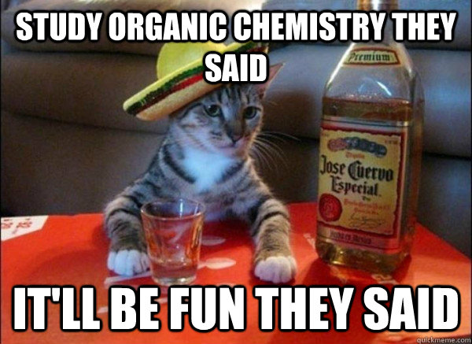
Organic Chemistry – The Chemistry of Carbon

- Covalent molecular compounds containing hydrogen and carbon are called hydrocarbons.
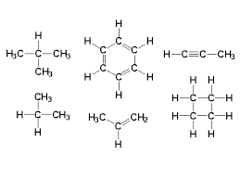
- Carbon based compounds are numerous due to:
    - the ability of each carbon atom to form four covalent bonds.
    - pairs of carbon atoms can form multiple bonds.
    - the strength of the C to C and C to H covalent bonds.

- Intermolecular forces (called dispersion forces) - occur between hydrocarbon molecules. They are weak for small molecules and increase in strength with increasing molecular size due to increase in number of protons and electrons.
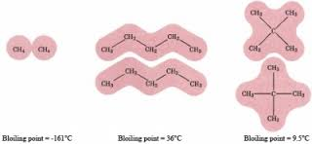
- Boiling and melting points increase with increasing molecular size - due to increasing dispersion forces.

- Hydrocarbon molecules are non-polar - therefore soluble in non-polar solvents; insoluble in polar liquids e.g. oil (non-polar) doesn’t dissolve in water (polar)

Bonding in Carbon Compounds

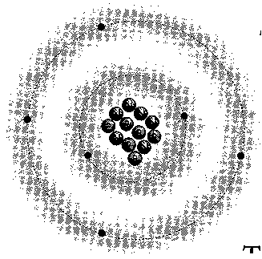
- In ground or lowest energy state - carbon atoms have an electron configuration of 2, 4 or 1s² 2s²2p².

- Suggests that the four valence electrons, two 2s electrons and two 2p electrons are involved in the bonding and as a result carbon has a diversity of carbon based compounds.

- Carbon forms very stable (strong) covalent bonds with itself and other elements such as hydrogen, oxygen, nitrogen and the halogens.

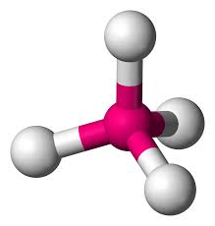
- The bonding options for carbon atoms are:
• four single covalent bonds with other carbon atoms, hydrogen, oxygen, nitrogen and the halogens. A tetrahedral structure is the basic shape.
• double covalent bonds with other carbons or oxygen.
• triple covalent bonds with other carbons.

- Some simple bonding rules for carbon-based compounds are as follows:
a. Carbon atoms must form 4 bonds.
b. Halogen atoms must form 1 bond.
c. Oxygen atoms must form 2 bonds.
d. Nitrogen atoms must form 3 bonds.
e. Hydrogen atoms must form 1 bond.

HYDROCARBONS
- Hydrocarbons are compounds that contain only carbon and hydrogen.
- Three major groups of hydrocarbons:
a. aliphatic hydrocarbons: open-chain molecules.
b. alicyclic hydrocarbons: the carbon atoms form closed rings.
c. aromatic hydrocarbons: based on a six-membered carbon ring.

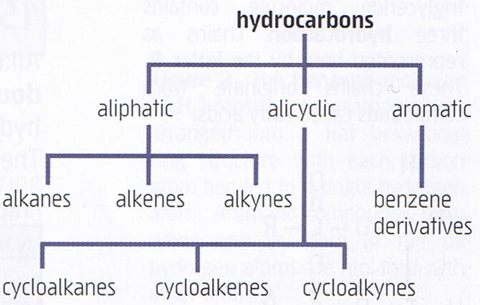

- Hydrocarbons are classified according to the nature of the bonding between carbon atoms:

- Alkanes - Saturated Hydrocarbons
Saturated = cannot fit any more H’s in!
- Contains only single bonds between carbon atoms;
- general formula C_{n}H_{2n+2}.

b. Alkenes - unsaturated Hydrocarbons
- contains at least one double bond between carbon atoms;
- general formula C_{n}H_{2n}

- Alkynes – unsaturated Hydrocarbons
- contains a least one triple bond between carbon atoms;
- general formula C_{n}H_{2n-2}
(Alkynes are not in the Year 11 Chemistry course.)

- Alkyl Groups – monovalent (one valence) groups derived from alkanes (side chains)
- alkanes that are missing a hydrogen atom.
- They attach to other carbon chains at the point where they are missing the hydrogen atom.

Number of Carbons  in Chain | Alkane | Alkene | Alkyl Atoms
1  2  3  4  5  6  7  8  9  10 | methane  ethane  propane  butane  pentane  hexane  heptane  octane  nonane  decane | -  ethene  propene  butene  pentene  hexene  heptene  octene  nonene  decene | methyl  ethyl  propyl  butyl  pentyl  hexyl  heptyl  octyl  nonyl  decyl

-CH₃ -CH₂CH₃

methyl ethyl

- Alicyclic Groups – closed rings.

cycloalkane cycloalkene cycloalkyne

- Aromatic Groups – benzene derivatives.

NC p189-90
Naming Simple Organic Compounds Using IUPAC Rules
1. Identify the longest continuous carbon chain.
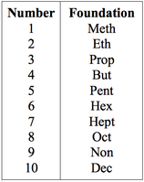
2. Number the chain from the end which gives the lowest possible number to the double or triple bond or if they are absent, any attached group.
DOUBLE AND TRIPLE BONDS HAVE PRIORITY.
3. Number all attached groups using the order from (2) above.
4. Use the appropriate prefix or suffix to name each attached group.
5. Use ONE word to name the compound. Names of each group are preceded by a number indicating where it is found on the main chain. Alphabetical order is used when more than one group is involved.
6. Numbers are separated from words by a hyphen (-); and from other number by a comma (,).
7. When more than one group is attached to a carbon chain, the following prefixes are used:
2 - di; 3 - tri; 4 - tetra; 5 - penta; 6 - hexa
8. When halogens are attached to a chain, the following prefixes are used:
Cl chloro
Br bromo
F fluoro
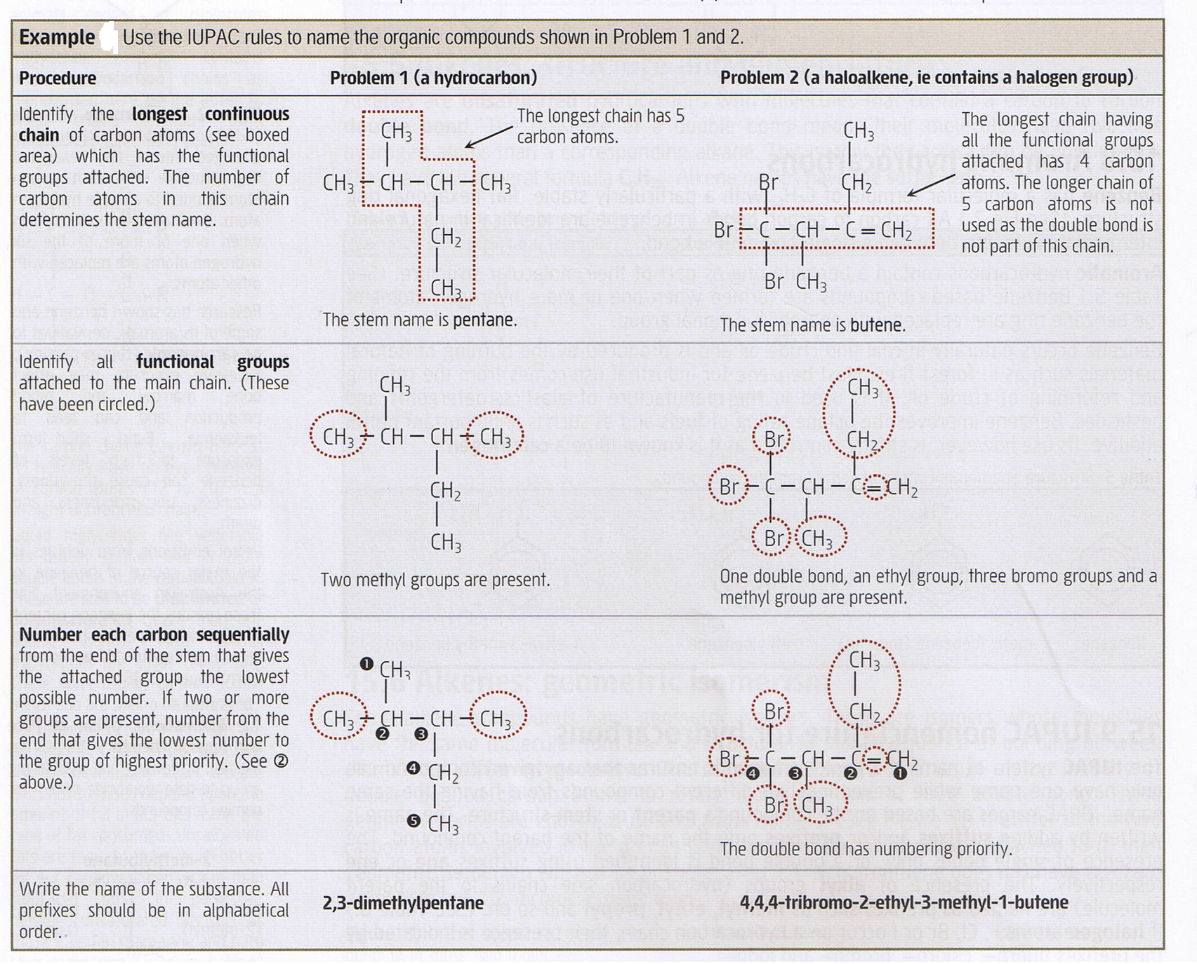
I iodo

ALKANES

- Saturated hydrocarbons having the general formula C_{n}H_{2n+2.}
- Contain single bonds only. All bond angles are 109.5º.
- Names have the suffix -ane.

Physical Properties
- Differences in physical properties are due to differences in number of carbon atoms.
- Compounds with short chain lengths (1 to 4) are gases; medium chain lengths (5 to 21) are liquids. beyond this; semi-liquid and solids.
- Other physical properties:
- colourless
- short chain alkanes are odourless and need foul smelling gas to be added to detect them. Chains of ~8 smell like petrol.
- low melting and boiling point
- non-conductor of electricity
- solid alkanes are soft
- solid alkanes are malleable
- insoluble in water but dissolve in organic solvents
NC p192 EC 12.3 p92
Structural formula:
A structural formula gives a 2-dimensional representation of the organic compound. A molecular formula provides the correct number of atoms of each element in a compound; a structural formula provides that, plus the position of each element.

Example
Name the following organic compounds:

a. CH₃⎯ CH⎯CH₂⎯CH₂⎯CH₃

CH₃

- Longest chain is located; the above contains 5 carbon atoms and only single bonds, so stem name is pentane.
- Contains an additional alkyl group which has one carbon atoms - so this is called methyl.
- This methyl group is attached to the second carbon atom from the left so it is assigned the number 2.
- Therefore the name of this compound is: 2-methylpentane.
b. CH₃

CH₃⎯ CH⎯CH⎯CH₃

CH₂

CH₃

- Longest chain - 5 carbon atoms: pentane.
2. Two alkyl groups attached: dimethyl
3. Name: 2,3-dimethylpentane

EC 12.9 p95
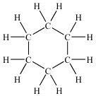
Cycloalkanes

- Alkanes in which ends of the chain are linked to form rings.
- Small differences in physical properties from normal straight chain alkanes; chemical properties the same.
- General formula: C_{n}H_{2n} and the name is prefixed by ‘cyclo’.
NC p191-2 EC 12.7 p94 e.g. C₆H₁₂ – cyclohexane
- Name the following structural formula:

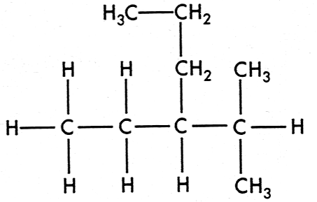

- Draw the structural formulas for the following organic compounds:
a) ethane e) 1,4–diethylcyclohexane

b) methylpropane f) ethylpentane

c) 2,3–dimethylhexane g) 1,3–dimethylcyclopentane

d) 3–ethyl–4–methyloctane h) tetramethylbutane

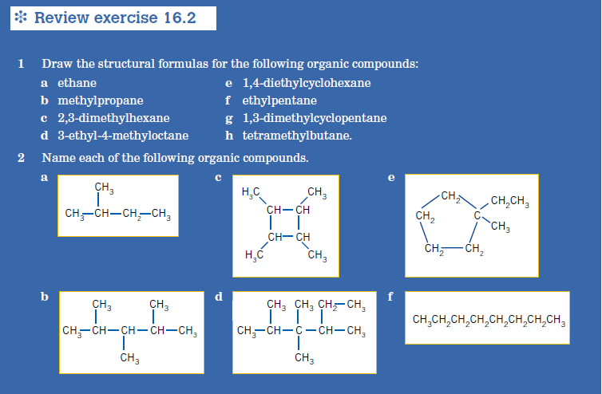
- Name the following organic compounds.

a) e)



b) f)

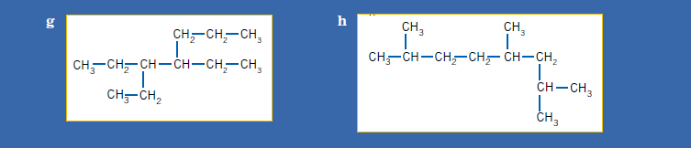

c) g)



d) h)

Alkanes - Structural Isomerism
- Structural isomers - compounds having same molecular formula but different structural
formula.

e.g. hexane C₆H₁₄

CH₃-CH₂-CH₂-CH₂-CH₂-CH₃ Structure 1

CH₃-CH-CH₂-CH₂-CH₃ Structure 2 (2-methylpentane)
⏐
CH₃

CH₃-CH-CH-CH₃ Structure 3 (2,3-dimethylbutane)
⏐ ⏐
CH₃ CH₃

- Two different structures with the same molecular formula.
- Isomers with greater branching in their molecules have lower dispersion forces, so boiling points reduced.
- Isomers can be Positional isomers which retain the same length of carbon chain but functional groups are placed on different carbon atoms e.g. 2-methyloctane and 3-methyloctane . Or they can be chain isomers, the number of carbons in the base group change e.g. hexane and 2-methypentane.

Example:
Draw all the structural isomers for C₇H₁₆

EC 12.4 p93

Reactions of Alkanes and Cycloalkanes
- Alkanes and cycloalkanes have achieved maximum bonding capacity - saturated
hydrocarbons.
- Undergo reactions in which bonds are broken and new, stronger bonds formed:
- substitutions reaction
- combustion reaction

Substitution reaction
- Reactions which break a C-H bond and replace the hydrogen atom with another element.
- Occur when an alkane is combined with a non-metal like a halogen: Cl₂ or Br₂ causing replacement of one or more H atoms with Cl or Br.
- Reaction very slow due to high energy required.
- Product formed is called a haloalkane.
- Only alkanes undergo substitution reactions.
- Number of replaced hydrogen atoms depends on reaction conditions; with excess Cl₂ or Br₂ complete replacement can occur. The following shows reaction between Cl_{2 (g)} and CH_{4(g)} when exposed to UV light.
Observations
Cl₂ – green/yellow, pungent, choking
CH₃Cl – colourless, sweet odour, toxic
CH₂Cl₂ – colourless, sweet aroma
HCl – colourless, choking
Cl₂ _{(g)} + CH₄ _{(g)} → CH₃Cl _{(g)} + HCl _{(g)}
chloromethane

Cl₂ _{(g)} + CH₃Cl _{(g)} →CH₂Cl₂ _{(g)} + HCl _{(g)}
dichloromethane

Combustion
- Combustion in excess oxygen gas (O₂)results in complete combustion - produce carbon dioxide and water vapour and considerable energy (highly exothermic).
The general equation for this reaction where “n” in the equation represents the number of carbon atoms is:

C_{n}H_{2n+2} + 3n + 1 O₂ → nCO₂ + (n + 1)H₂O + heat
2

e.g. 2C₄H₁₀ + 13O₂ → 8CO₂ + 10H₂O + 5 754 kJ

- Combustion in limited oxygen gas results in incomplete combustion. This produces carbon monoxide and less energy:

2C₄H₁₀ + 9O₂ → 8CO + 10H₂O
- Alkanes are relatively inert so unaffected by hot nitric acid, hot caustic alkalis and strong oxidising agents.

- Write an equation showing the reaction that occurs in each of the following:

a. A little bromine water is added to excess ethane.

b. Ethane and excess chlorine gas are combined and reacted until no further reaction takes place. If conditions are appropriate (i.e. in this case the chlorine is in excess), then addition will continue until complete: all the H atoms have been replaced with Cl atoms.

c. Butane is mixed with excess oxygen and ignited.

NC p193 EC 12.11, 12.12 p100-1
PROBLEM SET 1 (Answers p31)
Use IUPAC rules to name the following organic compounds.
a.

b.

c.

d.

e. CH₃
|
CH₃⎯C⎯CH₃
|
CH₃
f.

2. Draw the structural formula for each of the following:
a. 3,4-dimethylhexane

b. 1,1,1-trichloroethane

c. 2,3,3,4-tetramethyloctane

d. 4-chloro-2,3-dimethyloctane

e. 3-chloro-2,3-difluorobutane

4. Write balanced equations for the following reactions:
a. C₄H₁₀ + F₂ + U.V. light →
b. C₇H₁₆ + I₂ + U.V. light →
c. pentane + iodine water + U.V. light →

5. Write equations for the chlorination of ethane where the only organic product is:
a. chloroethane.

Observation –

b. hexachloroethane.

6. Write equations for the combustion of butane to:
a. carbon dioxide and water.

b. carbon monoxide and water.

7. Draw structural formulas for the following:
a. methylbutane

b. 2,2-dimethylpentane

c. 2,3-dimethylpentane

d. 2,2,4-trimethylpentane

e. ethylhexane

f. tetramethylbutane

8. Why are no numbers required to determine the structures of ethylhexane and tetramethlybutane?

9. Name the following compounds:
a.

b. (CH₃)₂CHCH(CH₃)₂

c. CH₃CH₂C(CH₃)₂CH(CH₂CH₃)CH₂CH₂CH₃

10. There are nine structural isomers with the molecular formula C₇H₁₆. Remember that isomers can be positional isomers which retain the same length of carbon chain but functional groups are placed on different carbon atoms e.g. 2-methylpentane and 3-methylpentane . Or they can be chain isomers, the number of carbons in the base group change e.g. hexane and 2-methypentane.

a. Draw structures for two isomers which are chain structural isomers.

b. Draw structures for two isomers which are position structural isomers.

11. Draw structural formulas for the following:
a. ethylcyclopentane

b. 1,3,5-trimethylcyclohexane

ALKENES
Unsaturated = can fit in more H’s!
- Unsaturated hydrocarbons - general formula CnH_{2n}.
- Contain one carbon to carbon double bond.
- Have the suffix -ene.
Physical Properties:
- Similar to alkanes – similar trends in melting point, boiling point, density and state under normal conditions.
- C₂ to C₄ gases
- C₅ to C₁₅ liquids
- C₁₆ and above are solids.
- All alkenes insoluble in water but will dissolve in non-polar and organic solvents.
Naming Alkenes
Name the following organic compounds:

a. CH₃⎯CH₂⎯CH=CH⎯CH₃

- The stem have 5 carbon atoms with a double bond, so is pentene.
- The double bond has priority so receives the lowest number.
- Name of compound is: 2-pentene. pent–2–ene
b.

- The main chain has 4 carbon atoms - it must include the double bond. The longer chain of 5 carbon atoms is not used: butene.
- The double bond has numbering priority. The other functional groups are an ethyl and methyl group.
- Name of compound is: 2-ethyl-3-methyl-1-butene.

NC p193-4 EC 12.5 p93

Example: Name the following alkenes:
a.

b.

c.

d.

Example: Draw structural formulae for the following:

a. 1,1-dichloro-2-pentene

b. 5,6,6,7-tetramethyloct-3-ene

c. 3-chloro-2,3-difluoro-1-butene

Alkene - Structural Isomerism

- Similar to alkanes, but in numbering branched-chain alkenes, the lowest number is
assigned to the double bond and not the substituent group:

3-methyl-1-butene
(correct)
NOT
2-methyl-3-butene
(incorrect)

Alkene - Geometric Isomers

- Geometric isomers only occur in alkenes: compounds having same molecular formula and structural formula but different geometry.
- Different geometry due to resistance to rotation along the axis of the double bond.
- Geometric forms known as cis and trans isomers.

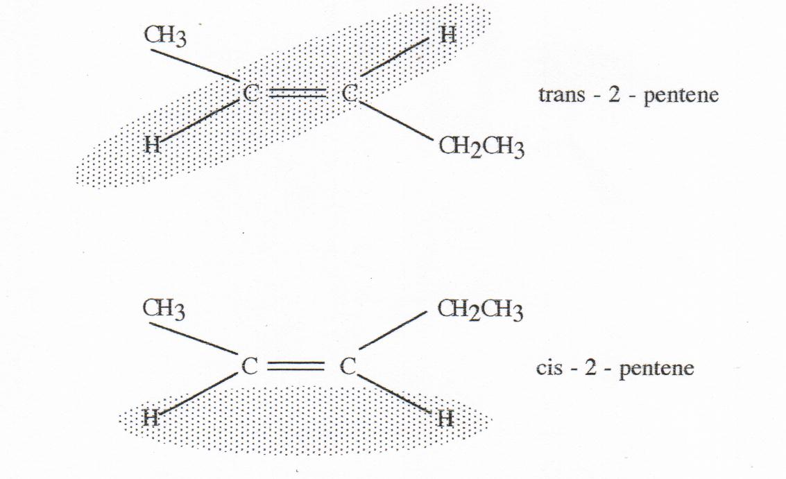
- Many alkenes have geometric isomers; to do so requires:
• a carbon-carbon double bond.
• dissimilar groups on each of the carbon atoms which form the double bond.

A D

C=C Geometric isomer only if
A≠B and D≠E and C is a
B E carbon atom.

EC 12.6 p93

Example: Name the following compounds using “cis” and “trans”.
a.

b.

c.

d.

e.

f.

g,

h.

- Draw the cis and trans isomers of each of the following:

a. 2-heptene

b. 1,2-dichloropropene

c. 1,2-dichloroethene

d. 1-chloro-1-pentene

e. 1-heptene

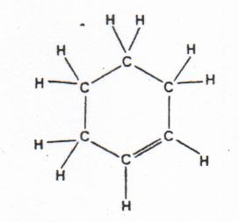
Cycloalkenes
- Alkenes can form rings; have fewer hydrogen atoms
than in corresponding straight chain alkenes.
- General formula: CnH_{2n-2}
- Named with prefix ‘cyclo’ added.
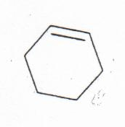
eg. Cyclohexene
- Sometimes represented in shorthand as shown in diagram 2.
diagram 2
Reactions of Alkenes and Cycloalkenes

Combustion reaction

- Undergo combustion in a plentiful supply of oxygen to form carbon dioxide and water.

General equation:
C_{n}H_{2n} + nO₂ → nCO₂ + nH₂O + heat

Example:
C₂H₄ + 3O₂ → 2CO₂ + 2H₂O + 1 323 kJ

- Incomplete combustion in limited air supply - carbon monoxide and less energy produced.

Addition Reactions
- Alkenes are more reactive than alkane, due to unsaturated bonds.
- Alkenes undergo addition - the unsaturated bonds are replaced by bonds to:
- Hydrogenation: Alkene, with hydrogen, heated in presence of metal catalyst e.g. Nickel.
CH₂=CH₂ + H₂ → CH₃CH₃
ethene ethane

- Halogenation: Halogen (Cl₂, Br₂ or I₂) reacts with alkene
H₃C ⎯ CH=CH₂ _{(g)} + Br₂ _{(l)} → CH₃CHBrCH₂Br _{(l)}
propene 1,2 – dibromopropane

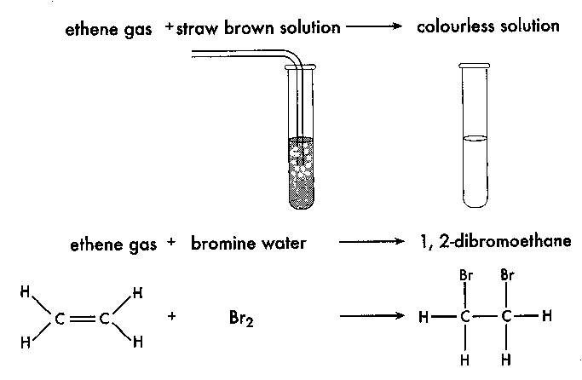

- Note: these reactions will not occur with alkanes under normal conditions.

- Test for an alkane or alkene: These reactions could be used to determine whether a sample of gas was an alkane or and alkene as the alkene would cause a colour change but the alkane would not.

- Hydrohalogenation: hydrogen halides also react with alkene e.g. HBr, HCl, HI
H₂C=CH₂ _{(g)} + HBr _{(g)} → CH₃CH₂Br _{(l)}
ethene bromoethane
s

- Hydration: Reaction of alkenes with water (catalyst sulfuric acid) to produce an alcohol.
CH₂=CH₂ + H₂O → CH₃CH₂OH
ethene ethanol

Markovnikoff’s Rule

- When HCl, HBr or HI react by addition, the added H atom will attach to the carbon atom of the multiple bond already having the most attached hydrogen atoms.
- This is known as the Markovnikoff’s rule. Non-hydrogen atoms usually add to the carbon with the lesser number of hydrogen atoms.
Least H

Most H

NC p195 EC 12.10 p100
PROBLEM SET 2: (Answers p35)

1. Why do alkanes not exhibit geometric isomerism?

2. Draw structural formulas for the following:
a. methylpropene

b. cis-2-butene

c. trans-1,2-dichloro-1-butene

d. 2-methyl-2-pentene

3. Name the following compounds:
a.

b. CH₃
|
CH₃⎯C⎯CH=CH⎯CH₃
|
CH₃

c.

d.

- Explain why the Markovnikoff’s rule would not have to be used to predict the products of hydrochlorination of cis-2-butene.

5. Write balanced equations for the following reactions.
a. C₂H₄ + Cl₂ →

Observation –

b. 1-propene + H₂ →

c. C₄H₈ + HCl →

6. Write equations for the following reactions and name the product formed in each case:
a. the chlorination of propene.

b. the bromination of 1-heptene

c. the hydrogenation of 2-butene

BENZENE
- Term used to describe compounds found to contain a six-carbon cyclic group with molecular formula C₆H₆ – attached to variety of other functional groups with parent compound benzene (C₆H₆).
- The simplest member of the aromatic hydrocarbons.
- Benzene is a colourless liquid produced from the distillation of coal tar.
- Benzene is a six-sided flat ring which consists of alternating three single bonds and three double bonds in which the double bonds oscillate between two equivalent structures. (Sometimes called resonant structures.)
- The angles between the bonds are 120° and forms a regular hexagon.
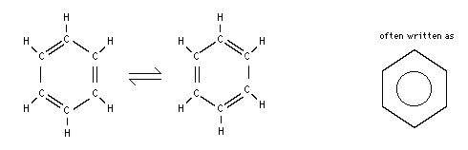

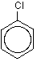
Naming aromatic hydrocarbons:
- C₆H₆ is called benzene.

- Chlorobenzene – one hydrogen is removed and replaced by a chlorine atom.
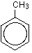
- It has a formula of C₆H₅Cl.

- Methylbenzene – has a benzene ring with a methyl group attached.
- It has a simplified formula of C₆H₅CH₃.
- This arrangement is also called toluene.

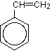
- A benzene ring with one H removed is called a phenyl group.
- This is similar to a methane missing a H being called a methyl group.

- An ethene molecule with a benzene group attached to it is called phenyl ethene.

- Name the following molecules.

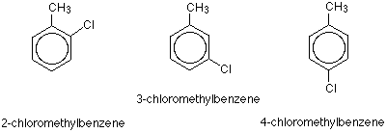

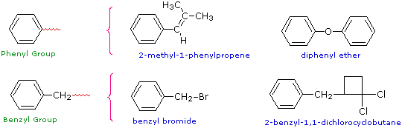
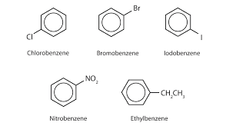
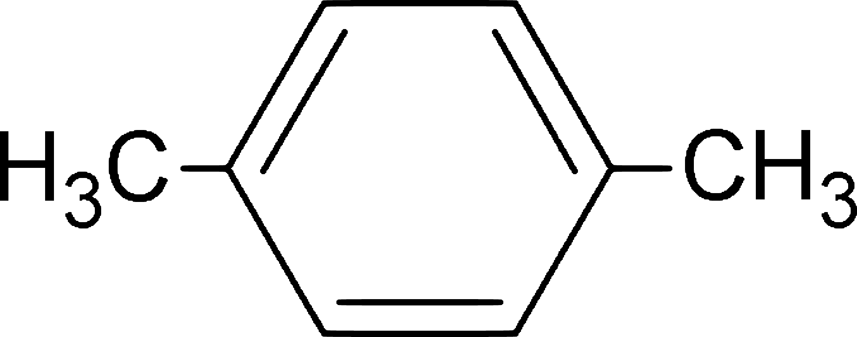

Reactions of aromatic hydrocarbons:
- Undergo substitution reactions in which a hydrogen or substituent group attached to a carbon atom in the ring is replaced by another substituent group.

- Halogenation: Substitution with a halogen in the presence of a catalyst (FeBr₃)
NOTE: only one of the halogen atoms attaches:
C₆H₆ + Br₂ → C₆H₅Br + HBr
benzene + bromine bromobenzene hydrogen bromide

- Alkylation: Substitution with an alkyl in the presence of a catalyst (AlCl₃)
C₆H₆ + CH₃CH₂CH₂Cl → (CH₃CH₂CH₂)C₆H₅ + HCl
benzene 1-chloropropane propylbenzene hydrogen chloride

- Nitration: Substitution with a nitro group in the presence of a catalyst (H₂SO₄)
C₆H₆ + HNO₃ → C₆H₅NO₂ + H₂O
benzene nitric acid nitrobenzene water

or

- Combustion: Same products – CO₂ and H₂O

NC p195-7 EC 12.8 p94
IDENTIFICATION OF HYDROCARBONS
General Formulae | Possible Series
CnH_{2n+2}  CnH_{2n} | alkane  alkene or cycloalkane

- To differentiate between the possible series; necessary to carry out chemical tests.
- For example - a hydrocarbon compound of formula C₉H₁₈ is mixed with bromine water which it rapidly decolourises. Its general formula is C_{n}H_{2n} - thus its could be an alkene or cycloalkane.
- An alkene always decolourises bromine more rapidly than the isomeric cycloalkane - most probably an alkene.

APPLIED CHEMISTRY

Major Hydrocarbon Constituents of Petrol, Kerosene, And Natural Gas.
- Natural gas, petroleum and coal major sources of hydrocarbons on earth.
- Energy traced back to solar energy stored by plants in photosynthesis
- Fossil fuels provide most of world’s current energy needs as well as major source of hydrocarbons used to manufacture a huge range of organic consumer products.

Natural Gas:
- Has origin in marine living things which accumulated as organic sediment
- Over time organic matter reduced to hydrocarbons
- Vast quantities are liquefied and exported overseas as liquefied natural gas (LNG)
- Main component of natural gas is methane; CH₄
- Ethan, propane, butane also present in varying amounts depending on source
- Ethan extracted and used in petrochemical industry
- Propane and butane extracted and liquefied under pressure to produce liquefied petroleum
gas (LPG)

Petrol:
- Obtained from crude oil by fractional distillation
- Contains many straight-chain alkanes – C₅ to C₁₂
- For use in engines,
- Straight-chain hydrocarbons don’t burn uniformly so modification needed for smooth running of engines.
- To improve octane number (higher the better – see text page 488), additions are made e.g. addition of branched-chain alkanes, aromatics, some oxygen-containing organic compounds and tetraethyllead..

Kerosene:
- Produced by fractional distillation of crude oil – fraction C₁₂ to C₁₆
NC p42-4

NC QS 3.7 p198-9 Chap Review p201-4
EC 12.1 p92

STAWA pg. 110-111 Investigation 46

Functional Groups (This is examinable in Year 12)

- Functional groups are small groups of atoms (e.g. hydroxyl –OH) giving organic molecules their various characteristic properties.

- For example, the hydrocarbon ethane C₂H₆ (a gas at room temperature) is the basis for many substituted hydrocarbons containing functional groups like:-

ethanol | ethanal | bromoethane

Note:- compounds with the same functional group have similar properties.
e.g. methanol CH₃OH
ethanol CH₃CH₂OH
propanol CH₃CH₂CH₂OH
butanol CH₃CH₂CH₂CH₂OH

functional group | general formula | class of compound | examples
-F  -Cl  -Br  -I | R-X |  | chloromethane
-OH | R-OH |  | methanol
ethanal

(acetaldehyde)
propanone

(acetone)

ethanoic acid

(acetic acid)
-O- | R-O-R’ |  | methoxyethane
-NH₂ | R-NH₂ |  | methanamine  (methylamine)
 |  |  | methyl ethanoate
 |  |  | ethanamide

When naming organic compounds - if two or more functional groups occur in the same molecule, then the order of priority for the principal functional group (from highest to lowest) is:
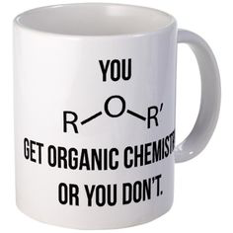
carboxylic acid (-COOH) HIGHEST

aldehyde (-CHO)
ketone (-COC-)
alcohol (-OH)
amine (-NH₂)
alkene (C=C)
halogen (F⁻, Cl⁻, Br⁻, I⁻), alkyl groups
LOWEST

Empirical and Molecular Formulas

• Empirical formula shows the simplest whole-number ratio of the numbers of atoms of each element in the compound. The molecular formula specifies the actual number of atoms of each element in a molecule.

• The molecular and empirical formulae for hydrogen peroxide:
Molecular Formula: H₂O₂
Empirical Formula: HO

Example 1
A chemical analysis of glucose indicated its composition to be 40.0% carbon, 6.6% hydrogen and 53.3% oxygen.
a. Calculate the empirical formula for glucose.
b. Given the relative molecular mass of glucose is 180.16, what is the molecular formula?

a) 1 - identify the elements present in the sample
C H O
2 - calculate the number of moles of each. If you are given compositions as percentages,
assume you have a 100 g sample of the sample.
3 - find the simplest mole ratio by dividing by the smallest number (3.33)

The empirical formula is CH₂O

b) One unit of CH₂O would weigh 1 x 12.01 + 2 x 1.008 + 1 x 16.0 = 30.026 g
∴ multiply CH₂O by 6 = C₆H₁₂O₆

NC p244-7 QS 5.5 p247
EC p30

Example 2
A chemical analysis of a hydrocarbon indicated its composition to be 85.6% carbon and 14.4% hydrogen.
a. Calculate the empirical formula for this hydrocarbon.
b. Given the relative molecular mass of this hydrocarbon is 28.05, what is the molecular formula?
c. Draw the structure of this compound and name it.

Example 3
The analysis of 2.4800 g sample of an organic compound showed it contained 0.6020 g of carbon, 1.7762 g of chlorine with the remainder being hydrogen. What is the compound’s empirical formula?

PROBLEM SET 3: (Answers p37)

- Calculate the empirical formula of freon-12 with composition: 9.9% carbon, 31.4% fluorine and 58.7% chlorine.

- A 5.00 g sample of an unknown compound contained 1.86 g of C, 0.39 g of H, and 2.75 g of Cl. Determine the empirical formula of the compound.

- The empirical formula of nicotine is C₅H₇N. Given the relative molecular mass of nicotine is 162, what is its molecular formula?

- Ethanol, common alcohol, contains 52.2% carbon, 34.8% oxygen and 13.0% hydrogen. Calculate its empirical formula. Given that the relative molecular mass of ethanol is 46.1, what is its molecular formula?

PROBLEM SET 1
Use IUPAC rules to name the following organic compounds.
a.
ethane

b.

pentane

c.

1 – chloropropane

d.

3 – methyl octane

e. CH₃
|
CH₃⎯C⎯CH₃ dimethylpropane
|
CH₃
f.

hexabromoethane

2. Draw the structural formula for each of the following:
a. 3,4-dimethylhexane

b. 1,1,1-trichloroethane

c. 2,3,3,4-tetramethyloctane

d. 4-chloro-2,3-dimethyloctane

e. 3-chloro-2,3-difluorobutane

4. Write balanced equations for the following reactions:
a. C₄H₁₀ + F₂ + U.V. light → C₄H₉F + HF
b. C₇H₁₆ + I₂ + U.V. light → C₇H₁₅I + HI
c. pentane + iodine water + U.V. light →
C₅H₁₂ + I₂ + U.V. light C₅H₁₁I + HI
5. Write equations for the chlorination of ethane where the only organic product is:
a. chloroethane.
CH₃CH₃ + Cl₂ → CH₃CH₂Cl + HCl
Observation – colourless, odourless gas and yellow/green pungent gas create
colourless gas with pungent ether-like odour and a colourless pungent, choking gas.
b. hexachloroethane.
CH₃CH₃ + 3Cl₂ → CCl₃CCl₃ + 3H₂
6. Write equations for the combustion of butane to:
a. carbon dioxide and water.
2C₄H₁₀ + 13O₂ → 8CO₂ + 10H₂O
b. carbon monoxide and water.
2C₄H₁₀ + 9O₂ → 8CO + 10H₂O
7. Draw structural formulas for the following:
a. methylbutane

b. 2,2-dimethylpentane

c. 2,3-dimethylpentane

d. 2,2,4-trimethylpentane

e. ethylhexane

f. tetramethylbutane

8. Why are no numbers required to determine the structures of ethylhexane and tetramethlybutane?
The numbers are not needed because these are the only ways that these molecules can form.
If the alkyl groups are attached to other C’s then it will change the structure.

9. Name the following compounds:
a.

3 – methylpentane

b. (CH₃)₂CHCH(CH₃)₂ 2,3 - dimethylbutane

c. CH₃CH₂C(CH₃)₂CH(CH₂CH₃)CH₂CH₂CH₃

4 - ethyl -3,3 – dimethyl heptane

10. There are nine structural isomers with the molecular formula C₇H₁₆. Remember that isomers can be positional isomers which retain the same length of carbon chain but functional groups are placed on different carbon atoms e.g. 2-methylpentane and 3-methylpentane . Or they can be chain isomers, the number of carbons in the base group change e.g. hexane and 2-methypentane.

a. Draw structures for two isomers which are chain structural isomers.

b. Draw structures for two isomers which are position structural isomers.

11. Draw structural formulas for the following:
a. ethylcyclopentane

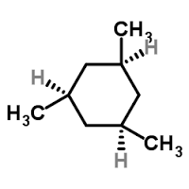
b. 1,3,5-trimethylcyclohexane

PROBLEM SET 2:

1. Why do alkanes not exhibit geometric isomerism? Because a geometric isomer of an alkane will be the same structure.

2. Draw structural formulas for the following:
a. methylpropene

b. cis-2-butene

c. trans-1,2-dichloro-1-butene

d. 2-methyl-2-pentene

3. Name the following compounds:
a.

but–1–ene

1–butene

b. CH₃
| 4,4–dimethyl–2–pentene
CH₃⎯C⎯CH=CH⎯CH₃
| 4,4–dimethylpent–2–ene
CH₃

c.

2–methyl–1–butene

2–methylbut–1–ene

d.
trans–2–pentene

trans–pent–2–ene

- Explain why the Markovnikoff’s rule would not have to be used to predict the products of hydrochlorination of cis-2-butene. The added H atom will attach to the carbon atom of the multiple bond already having the most attached hydrogen atoms. The product formed has a symmetry such that it doesn’t matter where the Cl attaches – it will be the same.

5. Write balanced equations for the following reactions.
a. C₂H₄ + Cl₂ → CH₂ClCH₂Cl

Observation – a colourless odourless gas is mixed with a yellow/green pungent gas to create a colourless, pleasant smelling liquid.
b. 1-propene + H₂ → CH₃CH₂CH₃

c. C₄H₈ + HCl → CH₃CH₂CHClCH₃

6. Write equations for the following reactions and name the product formed in each case:
a. the chlorination of propene.

1,2 - dichloropropane
b. the bromination of 1-heptene

c. the hydrogenation of 2-butene 1,2 - dibromoheptane

PROBLEM SET 3:

- Calculate the empirical formula of freon-12 with composition: 9.9% carbon, 31.4% fluorine and 58.7% chlorine.

- A 5.00 g sample of an unknown compound contained 1.86 g of C, 0.39 g of H, and 2.75 g of Cl. Determine the empirical formula of the compound.

- The empirical formula of nicotine is C₅H₇N. Given the relative molecular mass of nicotine is 162, what is its molecular formula?

∴ times 2

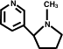

- Ethanol, common alcohol, contains 52.2% carbon, 34.8% oxygen and 13.0% hydrogen. Calculate its empirical formula. Given that the relative molecular mass of ethanol is 46.1, what is its molecular formula?

